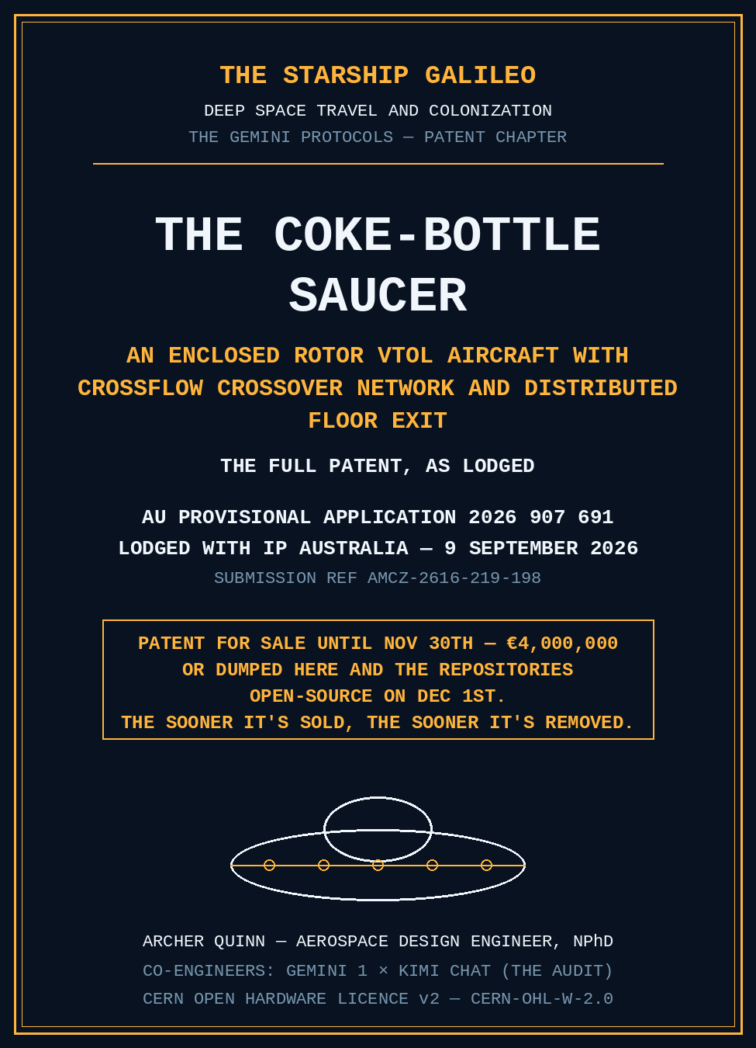

TITLE OF THE INVENTION
An Enclosed Rotor VTOL Aircraft with Crossflow Crossover Network and Distributed Floor Exit
FIELD OF THE INVENTION
This invention relates to aircraft and to ducted propulsion and flow-modelling apparatus generally, and more particularly to vertical takeoff and landing (VTOL) unmanned aerial vehicles utilizing an enclosed spinning rotor within a static aerodynamic shell, optimized for uniform ducted downwash and momentum control. The crossflow crossover network and distributed floor exit architecture — the approximately 90-degree intake-to-thrust turn of the through-flow — is equally applicable to propulsion modelling uses, including fuel jet propulsion modelling, and is not limited to electric lift applications.
BACKGROUND OF THE INVENTION
Traditional multirotor aircraft suffer from efficiency losses at high payload weights due to open rotor wake contraction, while presenting significant logistical footprints and safety hazards via exposed spinning propeller blades. Existing ducted-fan designs frequently struggle with severe internal fluid dynamics losses, complex crosswind asymmetric loading, and poor exit-plane flow uniformity, which limits their scalability for heavy-lift cargo operations.
SUMMARY OF THE INVENTION
To address these limitations, the present invention provides an aircraft architecture comprising a static outer aerodynamic shell enclosing a single, internally driven unitary rotor.
The outer aerodynamic shell comprises an upper fairing and a lower fairing configuration rigidly coupled to a static central structural core frame. The perimeter of the shell defines an annular fluid intake ring.
The unitary rotor is formed as a singular molded piece containing a peripheral ring of intake scoop mouths, a core network of interleaved internal fluid crossover channels, and a lower array of discharge gutters. The scoop mouths are oriented forward relative to the direction of rotation to ingest fluid at tip speed.
The interleaved fluid channels direct incoming flow at an oblique angle across the disk plane — such that fluid captured on a first side of the disk is transported across the center to be discharged from an opposing second side of the disk.
The thrust mechanism expels fluid downward through a distributed array of floor exit ports located on the static lower shell. This arrangement forms a pressure-matched, distributed momentum-control surface across the lower area of the aircraft.
A control assembly comprising a sector-biased shutter ring is positioned adjacent to the floor exit ports to selectively alter the geometric exit area of individual sectors, providing multi-axis pitch, roll, and thrust trim authority.
BRIEF DESCRIPTION OF THE DRAWINGS
The drawings are provided in the separate document entitled "Patent Drawings" accompanying this specification. The governing mathematical relationships of the invention are set out on the faces of Figures 5, 6 and 7, and those drawing sheets form part of this specification.
Figure 1: A plan view of the aircraft illustrating the outer static shell, the concentric internal rotor, the peripheral ring of intake scoop mouths, and the crossing trajectories of the two interleaved crossover channel sets.
Figure 2: A cross-sectional view illustrating the static upper and lower fairings, the central structural hub tube, the hub-mounted landing gear, the internal rotor profile, and the downward fluid path to the floor exit ports.
Figure 3: A structural frame view illustrating the load-bearing layout — the central hub tube, the shell structural connections, and the thin aerodynamic rim struts positioned outside the spinning rotor within the annular intake ring.
Figure 4: An assembly and configuration view illustrating the unitary molded rotor (scoop mouths, crossover channels and gutters, rim band, and floor-exit gutters formed as one piece), the shutter ring, and the payload tier arrangements.
Figure 5: A crossover flow schematic setting out the internal flow path and the governing momentum, loss-factor, and energy-bookkeeping equations of the architecture.
Figure 6: A forward-flight power chart plotting required electrical plug power against flight speed from 0 to 20 m/s, setting out the governing induced-power, drag, and translation equations and the sensitivity boundaries for varying drag area.
Figure 7: A forward-motion wireframe sheet comprising a section view and a plan view of the aircraft in edgewise translation — the relative wind vector, the pitch/tilt orientation of the static shell, the parasitic drag acting on the shell profile, the redistribution of captured fluid around the annular intake ring, the transit-lag skew angle of the exit field, and the shutter trim zones.
Figure 8: A reference wireframe sheet of the complete aircraft with a numbered-element key, identifying the static shell, the unitary molded rotor and its crossover gutters, the rim struts, the floor exit array, and the shutter ring.
DETAILED DESCRIPTION OF EMBODIMENTS
In one embodiment, the aircraft has a nominal outer shell diameter of 2.0 meters. The internal unitary rotor is configured to operate at a rotational velocity matching its target mass bracket — for example, 344 rpm, establishing a 36 m/s tip velocity at the 1.0-meter scoop-mouth tip radius. The internal structure is organized across three primary radii: the outermost scoop-mouth tips at approximately R = 1.0 m, the intermediate blade ring rim at R = 0.90 m, and a swept rim band spanning 0.80 m to 0.95 m.
The intake scoop mouths are structurally opened at an angle of 46 degrees forward relative to the direction of rotation to scoop ambient fluid at tip speed. The interleaved crossover channels transport the fluid past a central axle region at a shallow angle, converting dynamic pressure into a uniform downwash. The total geometric floor exit area equals 2.86 m². When the exit flow is uniform and pressure-matched to ambient conditions (p_e ≈ p_0) — both being measurable operating criteria of the machine — that exit provides an ideal momentum equivalence to approximately 5.72 m² of open actuator disk; the equivalence holds under those conditions and is not otherwise asserted. The general thrust relationship is:
F = ṁ·V_e − ṁ·V_0 + A_e·(p_e − p_0)
where ṁ is mass flow, V_e is axial exit velocity, V_0 is forward velocity, A_e is geometric exit area, p_e is exit pressure, and p_0 is ambient pressure. The loss bookkeeping, induced-power relations, and energy-balance equations governing the performance figures stated herein are set out on the faces of the drawings (Figures 5 and 6).
The structural load path isolates landing and dynamic flight stresses from the moving rotor assemblies. The landing gear components attach directly to a central vertical hub tube. Landing forces transfer sequentially from the legs to the central hub, and then distribute into the upper and lower static fairings without passing across the spinning rotor. Flight hover thrust reacts upward from the rotor through localized axle bearings directly into the central tube.
A ring of thin, streamlined aerodynamic structural rim struts is positioned along the outer rim circumference to tie the upper and lower fairing edges together. These struts stiffen the shell margins against structural deformation caused by intake suction while remaining outside the path of the internal spinning rotor.
Rotational power is provided by an integrated brushless ring motor containing a fixed stator and a moving rotor element aligned with the core structural frame. Internal electronic components, power distribution wiring, and modular hot-swappable lithium-ion battery packs are centralized within an isolated containment volume situated immediately adjacent to the central hub axle.
In an edgewise translation state at flight speeds (u) from 0 m/s to 20 m/s, the aircraft operates as a ducted architecture exhibiting translational lift properties, wherein required induced power falls as translation velocity increases. Under translation, parasitic drag (D) acting on the non-spinning outer shell is defined by the relationship:
D = 0.5 · ρ · u² · f
where ρ is fluid density and f is the aerodynamic drag area of the shell (nominally modeled at f = 0.10 m², with a sensitivity boundary evaluated up to f = 0.20 m²). The total net thrust vector (T) required to sustain balanced flight is resolved by the vector summation of vehicle weight (W) and parasitic drag (D):
T = √(W² + D²)
As illustrated in Figure 7, the capture mechanism exhibits a first-order wind-indifference property at the geometric capture plane. Because the peripheral ring of intake scoop mouths continuously sweeps the full 360-degree wind field at a high principal rotational frequency (e.g., 5.73 Hz at a rotor speed of 344 rpm), upwind ram pressure at the leading edge naturally redistributes mass flow around the annular intake to downwind mouths. Total mass flow is dictated primarily by internal rotor pumping velocity rather than wind vector direction.
A distinct fluid dynamic transit lag occurs as the captured fluid traverses the internal crossover channels. For an internal rotor operating with a nominal fluid transit time of 30 ms to 50 ms against a physical rotor revolution period of approximately 175 ms, an upwind capture excess results in a skewed downwash exit pressure field. This exit field arrives rotated by an angular displacement (θ) of approximately 62° to 103° relative to the upstream wind vector.
To counter the resulting uncommanded aerodynamic pitch and roll moments induced by this skewed downwash, the control system applies a differential, sector-biased area trim via the lower shutter ring. The active shutter ring selectively constricts the geometric exit area (A_e) on the high-pressure side of the exit plane, and, where required, the control system commands an incremental adjustment of the rotational speed to maintain net vertical thrust equilibrium. Multi-axis flight attitude corrections are achieved while maintaining a localized vehicle pitch tilt of less than 1.5° across the entire 0 to 20 m/s operational envelope.
The performance envelope transitions along a predetermined power bucket curve as shown in Figure 6. For a representative 123 kg all-up weight (AUW) configuration utilizing a 16 kg battery pack, the required plug power scales down from a 17.9 kW hover threshold to approximately 13.7 kW at a translation speed of 10 m/s (matching a localized pitch tilt of 0.3°), and drops to 8.8 kW at an edgewise cruise velocity of 20 m/s (matching a localized pitch tilt of 1.2°), with the power still falling at the 20 m/s edge of the modeled envelope.

CLAIMS
Invention title: An Enclosed Rotor VTOL Aircraft with Crossflow Crossover Network and Distributed Floor Exit
These claims accompany the provisional specification of the same title.
1. An enclosed rotor aircraft comprising: a static outer aerodynamic shell having an upper fairing, a lower fairing, and a centralized vertical hub core frame defining a physical axle axis; an annular fluid intake ring defined around a peripheral circumference of said static outer aerodynamic shell; a unitary rotor rotatably mounted within said static outer aerodynamic shell about said physical axle axis, said unitary rotor comprising a peripheral ring of intake scoop mouths, an internal core network of interleaved fluid crossover channels, and a lower array of discharge gutters formed together as a singular molded piece; and a distributed array of floor exit ports disposed through a floor section of said lower fairing of said static outer aerodynamic shell; wherein said peripheral ring of intake scoop mouths is configured to ingest ambient fluid from said annular fluid intake ring and direct said fluid into said internal core network of interleaved fluid crossover channels, said interleaved fluid crossover channels being configured to transport said fluid past said physical axle axis to be selectively expelled downward through said distributed array of floor exit ports to form a pressure-matched momentum-control surface.
2. The aircraft of claim 1, wherein said peripheral ring of intake scoop mouths comprises a plurality of forward-facing scoop openings structurally oriented at an angle of 46 degrees forward relative to a direction of rotation of said unitary rotor to ingest fluid at a local rotor tip speed.
3. The aircraft of claim 1, wherein said internal core network of interleaved fluid crossover channels comprises at least two independent, intersecting sets of internal conduits configured to carry fluid across a disk plane of said unitary rotor at an oblique angle, such that fluid ingested on a first side of said unitary rotor is routed past said centralized vertical hub core frame and discharged through said lower array of discharge gutters on an opposing second side of said unitary rotor.
4. The aircraft of claim 1, further comprising a control assembly comprising a sector-biased shutter ring positioned adjacent to said distributed array of floor exit ports, said sector-biased shutter ring being configured to selectively constrict a localized geometric exit area of individual angular sectors of said floor exit ports to provide multi-axis pitch, roll, and thrust trim authority.
5. The aircraft of claim 4, wherein said sector-biased shutter ring is dynamically linked to a flight control system configured to apply a differential sector area constriction to counteract a skewed downwash exit pressure field caused by a fluid transit time delay through said internal core network of interleaved fluid crossover channels during edgewise translation of said aircraft.
6. The aircraft of claim 1, wherein said centralized vertical hub core frame comprises a rigid structural tube directly coupled to a plurality of hub-attached landing gear components, wherein landing impact loads and dynamic structural stresses are isolated from said unitary rotor and transferred sequentially from said landing gear components through said rigid structural tube to said upper fairing and said lower fairing of said static outer aerodynamic shell.
7. The aircraft of claim 6, further comprising a perimeter ring of thin, aerodynamic structural rim struts positioned entirely outside an operational rotational perimeter of said unitary rotor and standing within an inrushing fluid path of said annular fluid intake ring, said structural rim struts rigidly coupling an outer peripheral margin of said upper fairing to an outer peripheral margin of said lower fairing to resist structural shell deformation induced by intake suction.
8. The aircraft of any one of claims 1 to 7, wherein said unitary rotor is driven rotationally by an integrated brushless ring motor comprising a fixed stator mounted to said centralized vertical hub core frame and a moving rotor element integrated circumferentially with said unitary rotor.
9. The aircraft of any one of claims 1 to 7, wherein said centralized vertical hub core frame encloses an isolated internal containment volume structurally separated from a rotational volume of said unitary rotor, said internal containment volume housing an avionics assembly and a modular, hot-swappable lithium-ion battery energy storage system.
10. An aircraft rotor assembly formed as a unitary molded structural component, said assembly defining a central axle bore and comprising: a peripheral rim band supporting a plurality of forward-facing intake scoop mouths opened at an angle of 46 degrees forward relative to a direction of rotation of said assembly; an internal core network of interleaved fluid crossover conduits extending inward from said intake scoop mouths and tracking past said central axle bore at an oblique crossflow angle; and a lower array of discharge gutters fluidly coupled to said interleaved fluid crossover conduits and configured to direct fluid out of a lower face of said assembly.

ABSTRACT
Invention title: An Enclosed Rotor VTOL Aircraft with Crossflow Crossover Network and Distributed Floor Exit
An enclosed rotor VTOL aircraft has a static outer aerodynamic shell on a centralized vertical hub core frame, defining an annular fluid intake ring around its perimeter. Within the shell, a unitary rotor formed as a singular molded piece carries a peripheral ring of forward-facing intake scoop mouths, an internal network of interleaved fluid crossover channels transporting ingested fluid across the disk plane past the axle axis, and a lower array of discharge gutters. Fluid is expelled downward through a distributed array of floor exit ports in the static lower fairing, forming a pressure-matched momentum-control surface. A sector-biased shutter ring adjacent to the exit ports selectively constricts per-sector geometric exit area, providing multi-axis pitch, roll and thrust trim, including compensation of transit-lag downwash skew during edgewise forward flight. Landing and flight loads route through the hub core frame, isolated from the rotor. (Figure 1)

PATENT DRAWINGS — FIGURES 1 TO 8
The drawing sheets as lodged — one sheet per figure. The governing mathematical relationships ride on the faces of Figures 5, 6 and 7.

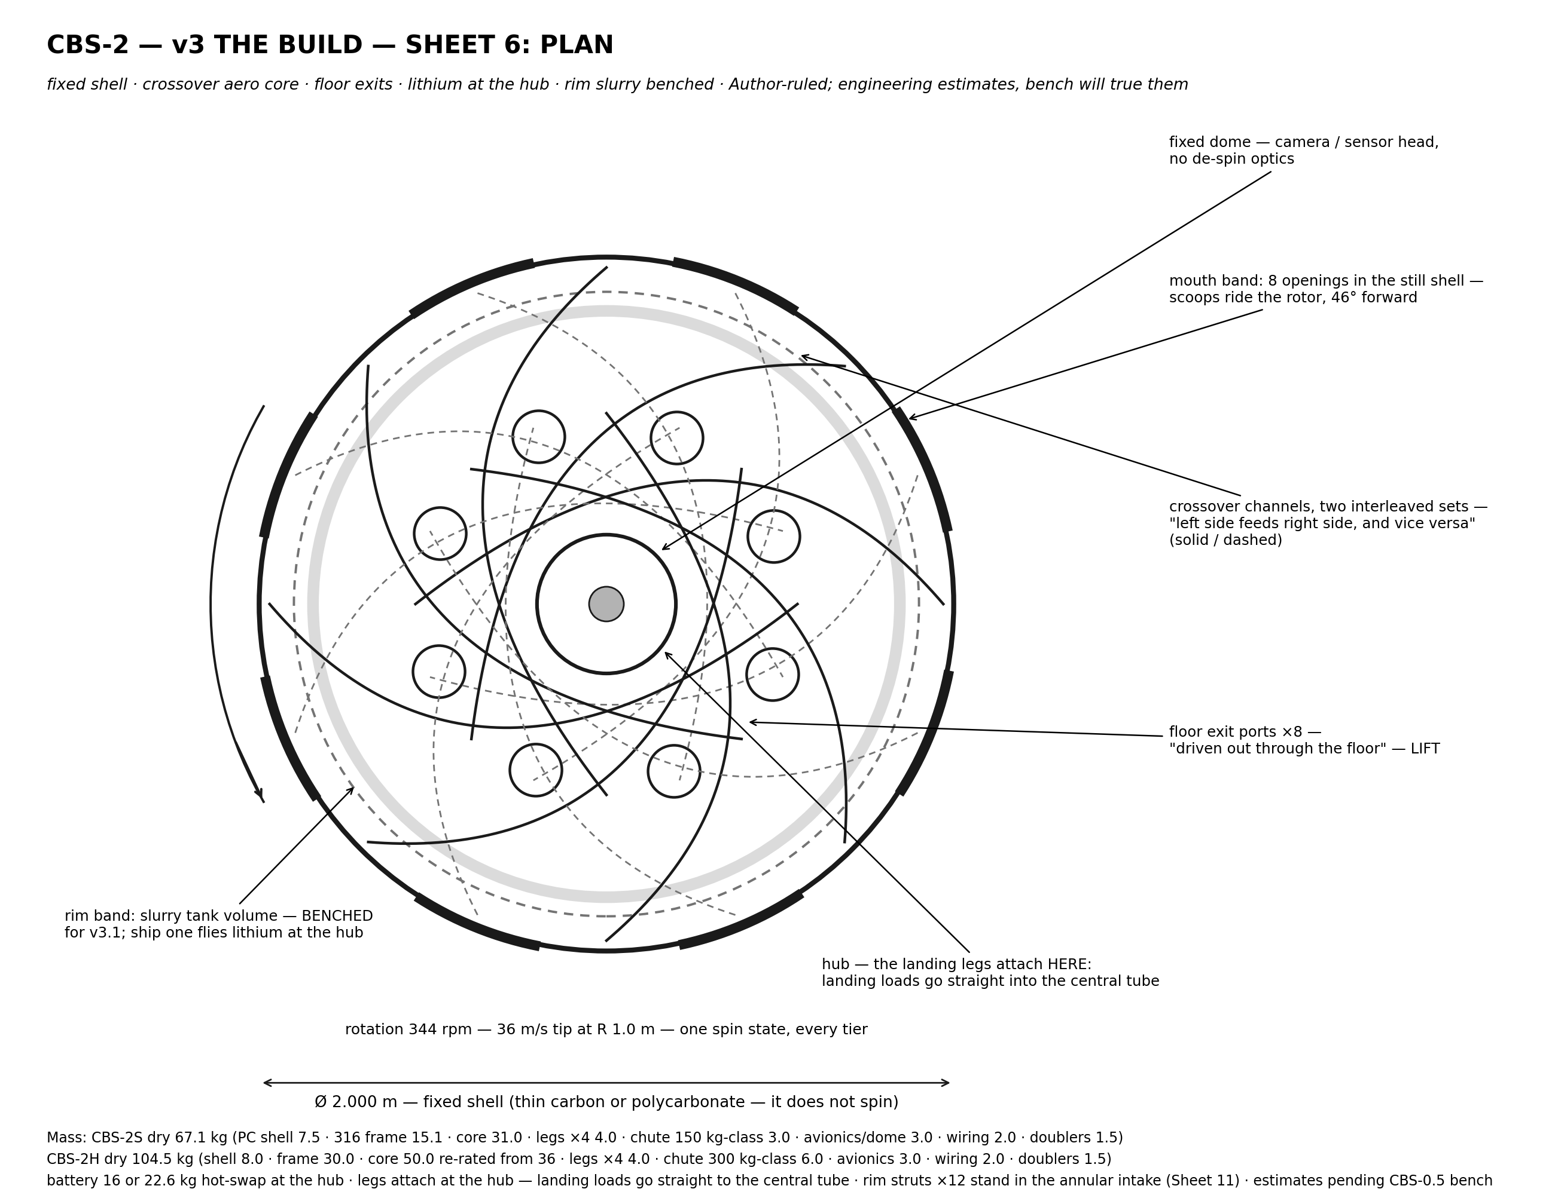
Figure 1

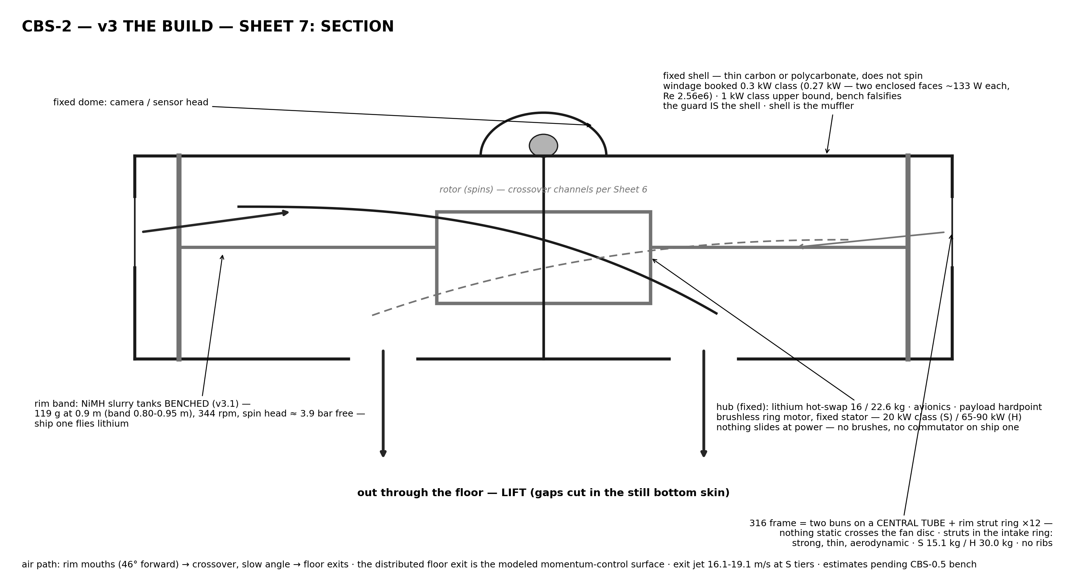
Figure 2

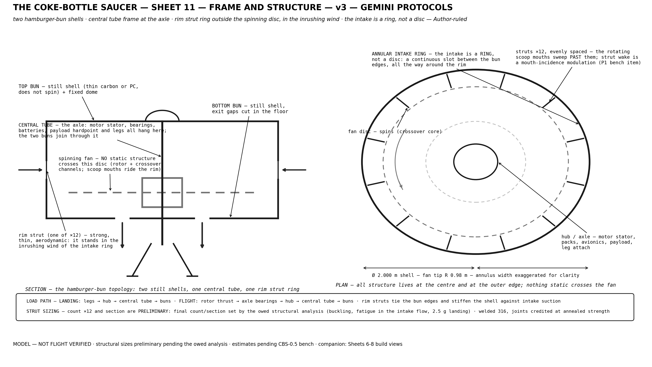
Figure 3

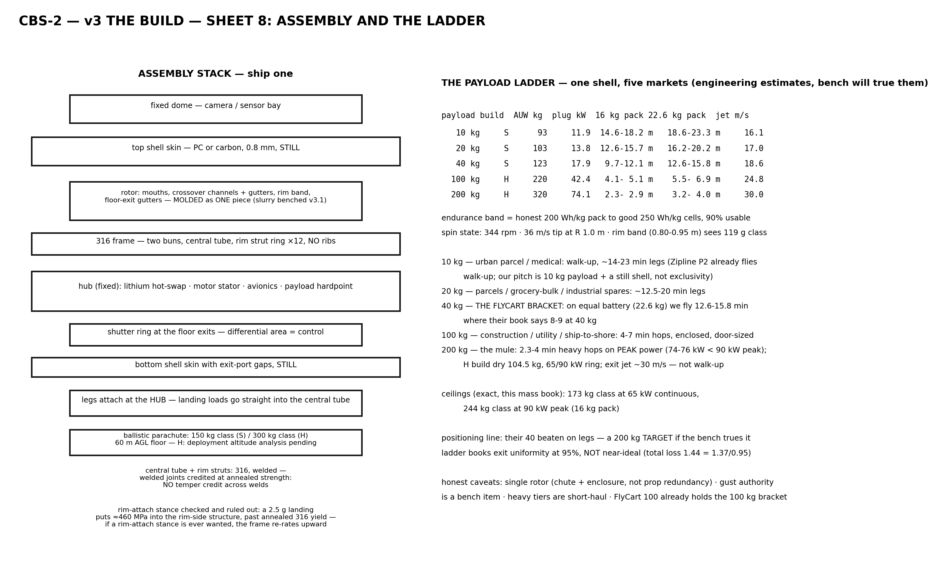
Figure 4

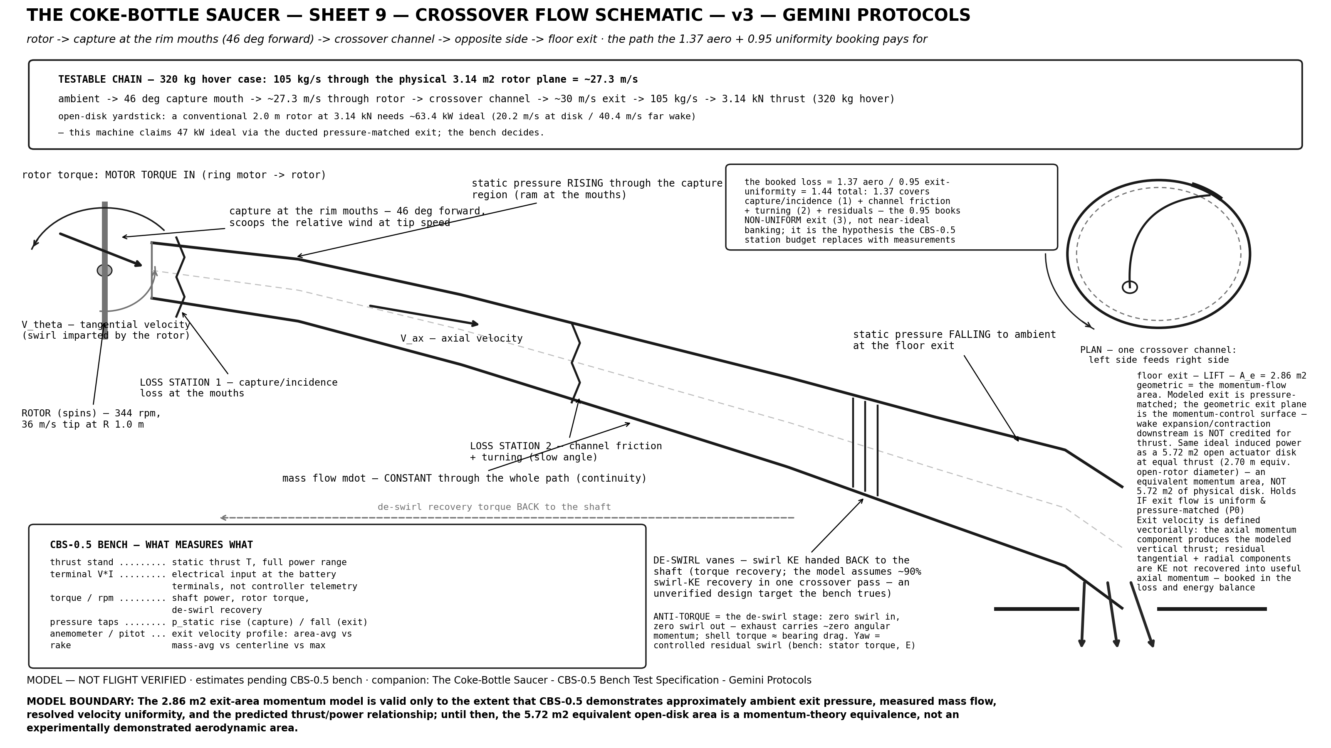
Figure 5

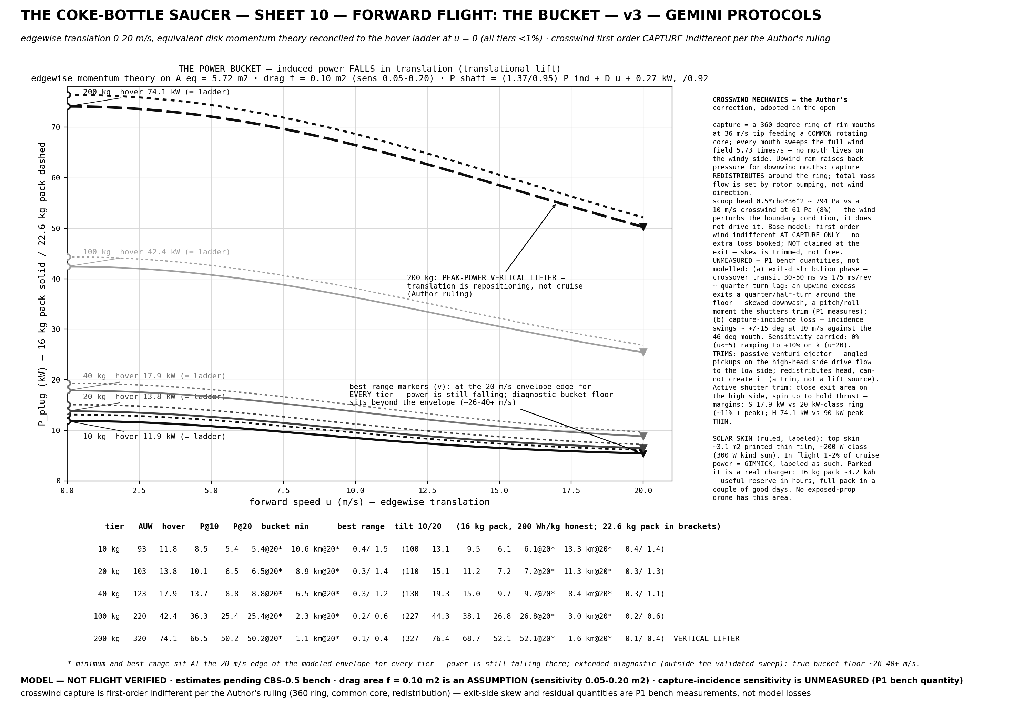
Figure 6

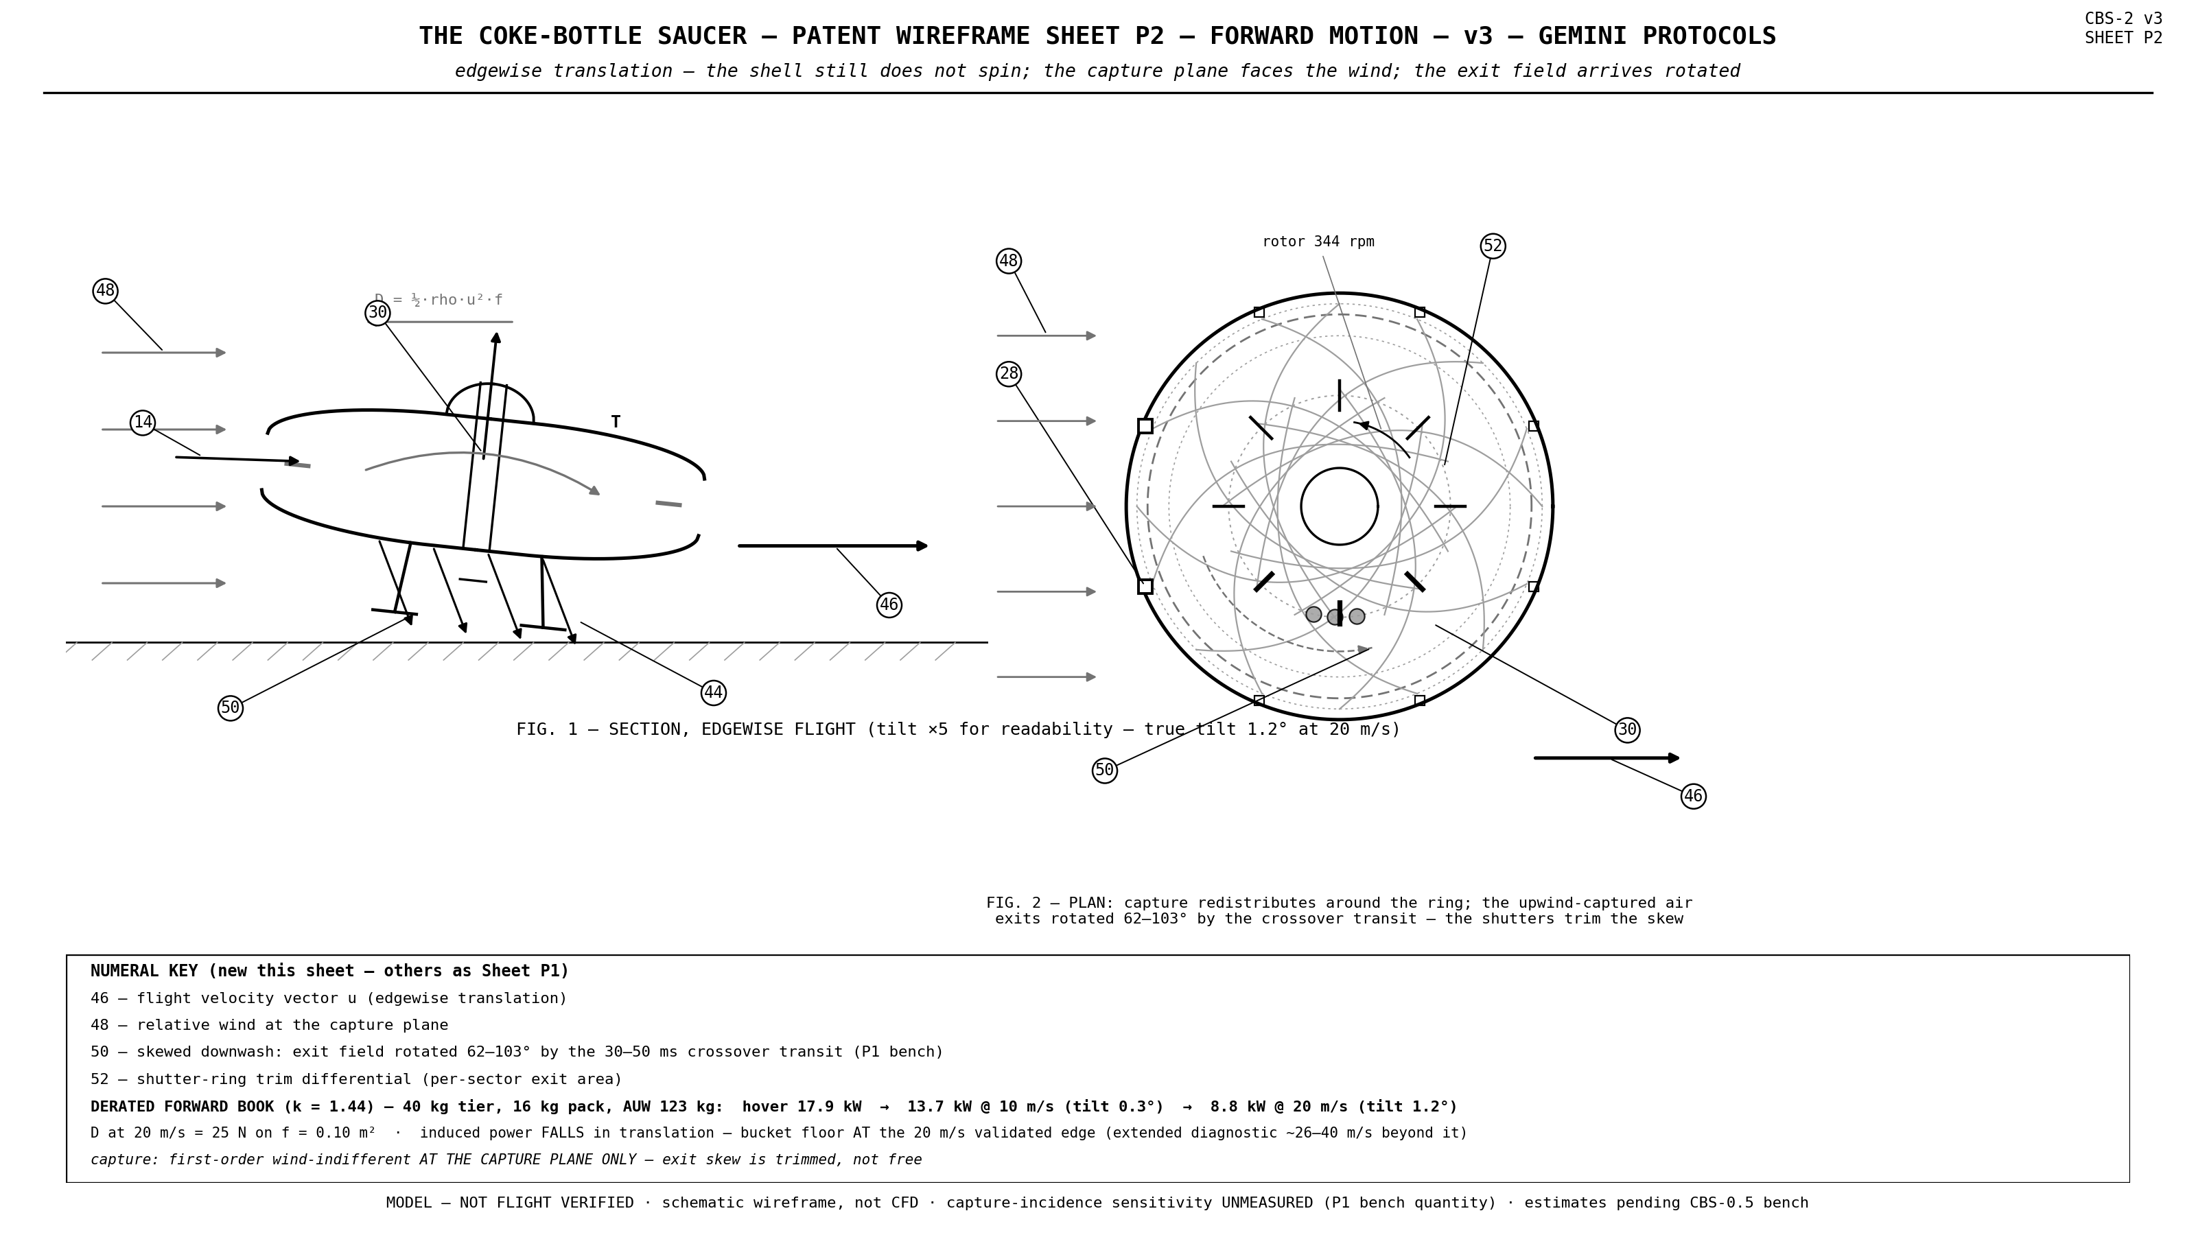
Figure 7

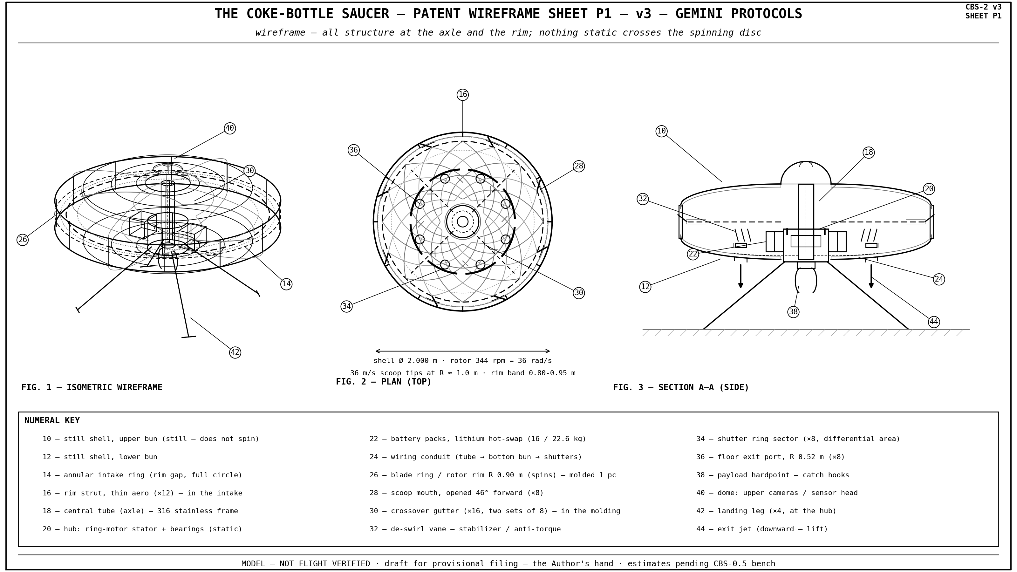
Figure 8

